UNIFORM SHOP

Open Monday: 2.00 – 3.30pm
Friday: 8.30 – 10.00am

The uniform shop keeps prices at a minimum to assist parents. The P&C Uniform Shop is a service providing new garments as well as a secondhand clothing pool ($5 per item). The uniform shop is located in the last room, on the ground floor, Myahgah building.
Orders can be made online via www.flexischools.com.au.
Accepted methods of payment: cash, cheque or Eftpos (Visa, Mastercard only – No Amex).
Exchanges or refunds are accepted provided the item/s are kept in their original package with tags attached.
Queries: uniformmosmanps@gmail.com
Equipment All students will need a school bag, hat, a homework bag, a library bag, suitable rainwear and a painting shirt. Parents are urged to ensure that all clothing, (including shoes and socks) is clearly marked with their child’s name.
- No umbrellas at school or on any school excursion
- No coloured laces in black joggers/trainers
- Coloured joggers/trainers are not part of the school uniform

UNIFORM
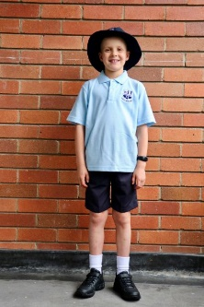
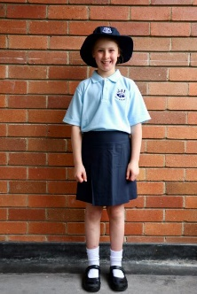
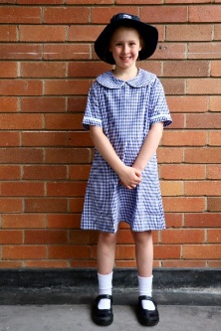
Summer uniform options

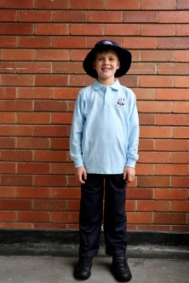
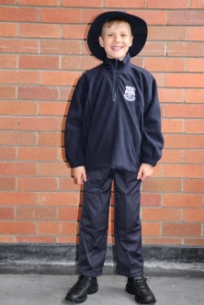
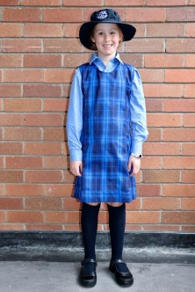
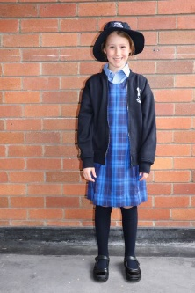
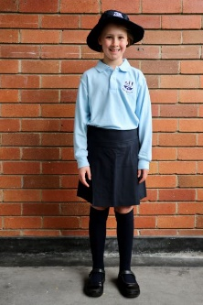
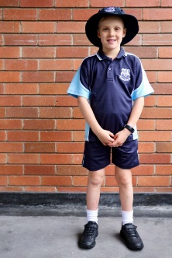
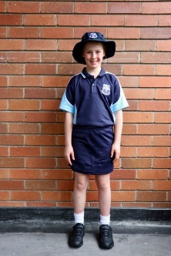
Winter uniform options

Sport uniform worn every Tuesday & Friday
Sport options

UNIFORM PRICE LIST

Season | Item | Available sizes | Price
Summer | Navy shorts | 3, 4, 6, 8, 10, 12+ | $22
 | Pale blue polo (short sleeves) | 4, 6, 8, 10, 12+ | $22
 | Dress | 4, 5, 6, 8, 10, 12+ | $47
 | Navy tailored skort | 2, 4, 6, 8, 10, 12+ | $28
Winter | Navy trousers (straight leg) | 3, 4, 6, 8, 10, 12+ | $30
 | Navy pleated trousers | 3, 4, 6, 8, 10, 12+ | $30
 | Pale blue polo (long sleeves) | 4, 6, 8, 10, 12+ | $30
 | Tunic | 4, 5, 6, 8, 10, 12+ | $50
 | Skivvy (pale blue turtleneck) | 4, 6, 8, 10, 12+ | $15
 | Long sleeved blue shirt (worn under tunic) | 4, 6, 8, 10, 12+ | $25
 | Sport Uniform
 | Sport shorts | 4, 6, 8, 10, 12+ | $25
 | Sport skort | 4, 6, 8, 10, 12+ | $25
 | Navy blue sport polo (short sleeves) | 4, 6, 8, 10, 12+ | $25
 | Tracksuit Trousers (straight leg & cuffed) | 3, 4, 6, 8, 10, 12+ | $25
Warm Tops/ Fleeces | Polar Fleece (half-zip) | 4, 6, 8, 10, 12+ | $40
 | Fleecy Zip Jacket | 3, 4, 6, 8, 10, 12+ | $35
 | Polar Fleece Vest | 4, 6, 8,10, 12+ | $32
 | Crew neck tracksuit top | 4, 6, 8, 10 , 12+ | $25
Hats
Bucket Hat |  | S/M, M/L, L/XL | $15
Surf Hat |  | S, M, L | $15
Hair Accessories
Scrunchie |  | Summer/ Winter | $7
Headband |  | Summer/ Winter | $8
Bags
School backpack bag |  |  | $50
Library/excursion bag |  |  | $18
Homework Bag |  |  | $20
Miscellaneous
Socks knee high Navy (2 pairs) |  | 5-7yrs, 7-10yrs, 10+yrs | $10
Socks white ankle |  | 5-7yrs, 7-10yrs, 10+ yrs | $3
Tights navy |  | 4-6yrs, 7-10yrs, 11-14yrs | $10
Modesty shorts (worn with Summer dress & Tunic) |  | 4, 6, 8, 10, 12 | $15
Rain jacket (short) |  | 4, 6, 8, 10, 12, 14 | $30
Instrumental polo |  | 8. 10, 12, 14 | $39

