Mosman Public School

Kindergarten 2022

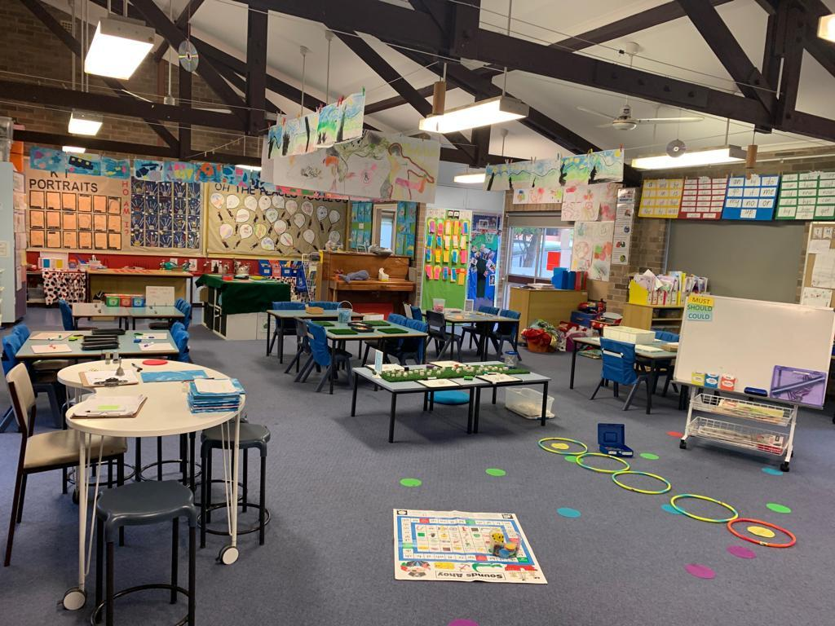
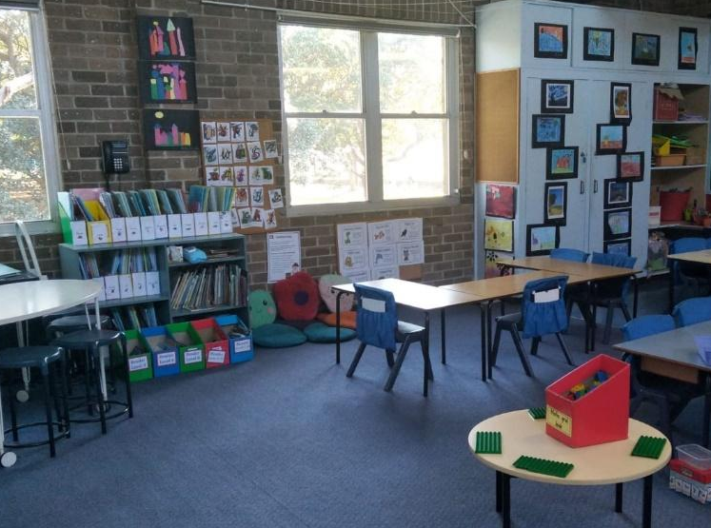
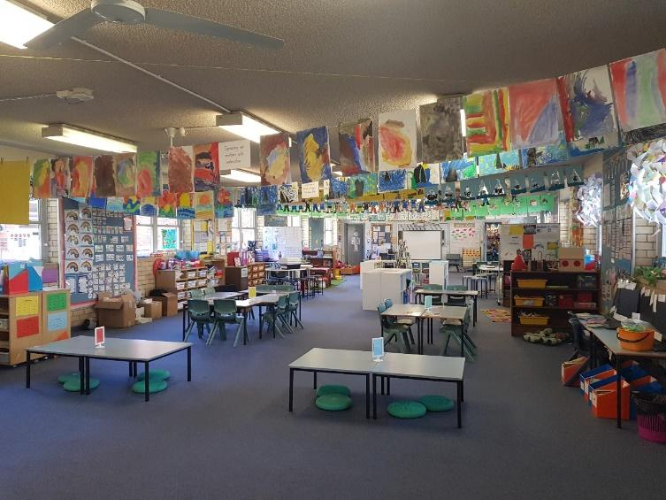
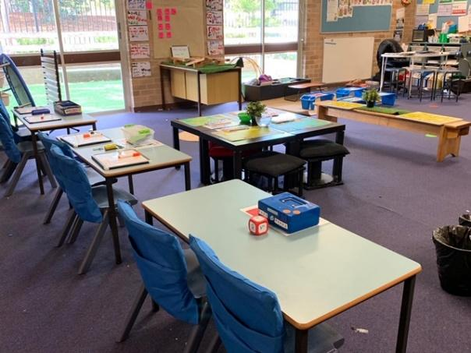

Key Information Regarding the Best Start Kindergarten Assessment

The Best Start Kindergarten Assessment will take place in all schools across NSW in Term 1, 2022.

The Best Start Assessment is not a test. It is a process whereby your child’s teacher observes and records what your child already knows and can do in literacy and numeracy. This information is used to guide teaching and support students’ individual learning needs.

More information on Best Start Kindergarten Assessment can be found at https://education.nsw.gov.au/teaching-and-learning/curriculum/literacy-and-numeracy/best-start

Key Dates for Kindergarten 2022

Tuesday February 1, 2022 | Best Start Assessments - no Kindergarten classes.  A letter will be posted with the date and time of your child’s Best Start Assessment.
Wednesday February 2, 2022
Thursday February 3, 2022
Friday February 4, 2022 | Kindergarten classes commence.  Please be aware that students have staggered starting times.  Your child’s start time will be given to you at the Best Start Assessment. Thank you for your assistance in being punctual to your allocated time.

Uniform Information

The following is a list of the recommended uniform for a child starting Kindergarten.

School Uniform Options
2 x summer dress OR
2 x navy tailored skort with 2 x pale blue polo sport shirt OR
2 x navy shorts with 2 x pale blue polo sport shirt

1 x School hat
1 x School backpack
1 x School excursion bag
1 x School Library/homework bag
Sport Uniform Options
1 x sport skort with 1 x navy blue sports polo OR
1 x sport shorts with 1 x navy blue sports polo

Optional Extras
White ankle socks
Headband
Scrunchie
Raincoat (long or short)
Polar fleece
Polar vest
Zipped track top
Crew neck tracksuit top

All students must wear plain black shoes/trainers/sneakers, which can be purchased from children’s shoe shops or sports stores. Socks should be white and cover the ankle.

2022 Kindergarten Transition Uniform Shop opening hours will be communicated to you when NSW Health regulations permit on-site visitation.

Preparing Your Child for School

Help your child to practise the following skills:
- using pencils, scissors and a glue stick
- writing their name with a capital letter for the first letter and lower case for the rest, e.g. Mary Thomas
- independently opening their school food containers
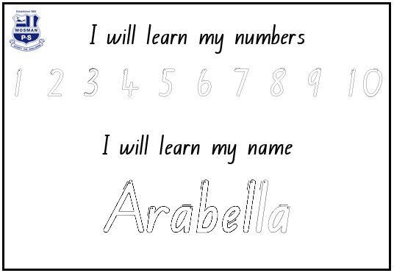
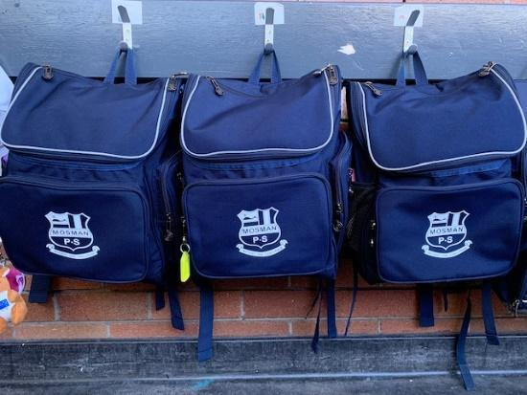

Talk to your child about school routines:
- eating lunch and afternoon tea at set times
- being responsible for their own belongings
- working and playing with others
- sharing toys, games and pencils, etc
- arrangements for drop-off at school each morning and arrangements for pick-up each afternoon. It is important that your child to knows the arrangements.

Your child will need to bring the following to school each day:
- hat
- school bag
- reading folder
- library bag [on designated library days]
- crunch and sip [snack of fruit or vegetables and water]
- lunch
- afternoon tea
- spare pair of underpants in a plastic bag in their school bag

Once your child starts school you can help them in the following ways:
- allow plenty of time for getting up in the morning so you are not rushing
- be cheerful, confident and positive about school
- in the morning, leave your child at the line up area - say goodbye cheerfully and firmly, do not escort them into the classroom
- be on time to collect your child
- show that you are interested in what your child does during the school day [Ask your child questions like “Did you read a book today?” Please do not be concerned if they do not want to discuss this or say they cannot remember]
- check bags for notes, particularly on Wednesday
- encourage regular and punctual attendance-provide a written note for any absences
- encourage your child to have a go and that it is okay to make mistakes
- invite friends for play dates as this is important in their social development
- most importantly, please schedule an appointment to talk to your child’s class teacher if you or your child are experiencing any problems or difficulties

Kindergarten expectations
We hope that by the end of the year in Kindergarten, your child will:

- be happy at school and enjoy coming to school
- have made friends with other children
- have a love of learning
- be willing to join in school activities
- have made sound academic progress.

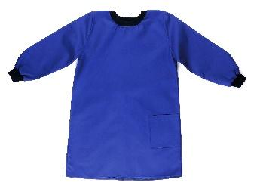
During the first week of school please send in the following:

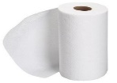
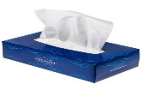
- 1 x labelled paint smock (an old adult t-shirt is preferable, no button up shirts)
- 2 x kitchen paper towel
- 2 x box of tissues
- 1 x baby wipes or hand sanitizer
- 1 x star of the week photo [Each Kindergarten class participates in the star of the week program. The aim of this program is to boost each child’s self-esteem and make them feel special. We do this by giving each child the opportunity to be the star of the week. A special poster is made about each child and is displayed on the classroom window for the week. We like to stick a photograph of the child on the poster. The photograph you send needs to be a recent one and a standard portrait size. Remember it will be stuck onto the poster and laminated so please send a photograph that does not need to be returned].
- 1 or 2 x family photo [send 1 or 2 photos of your family portrait or landscape]. These will be displayed in your child’s classroom to support the ‘Personal and Family’ History unit taught in Term 1.

Reading Folders
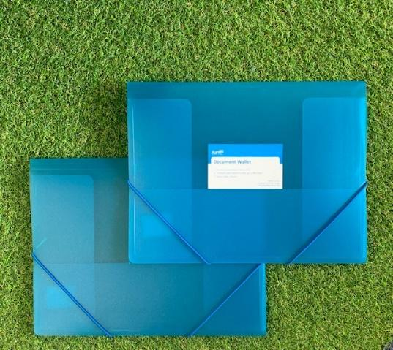
Each student will receive a reading folder that is included in the school starter stationery pack. It is very important that this is brought to school daily and should be placed in the allocated box/space upon entry to the classroom. The reading folder is used to send readers and notes to and from school. If readers are not returned, students will not receive a new reader for the next day. The teachers check the folders every morning and clear out any notes or messages from you.

Labelling
Please label everything that belongs to your child. Label it with something that will not rub or come off and label it in an obvious, visible place. Things that need labelling include:
- hat
- t-shirts
- shorts
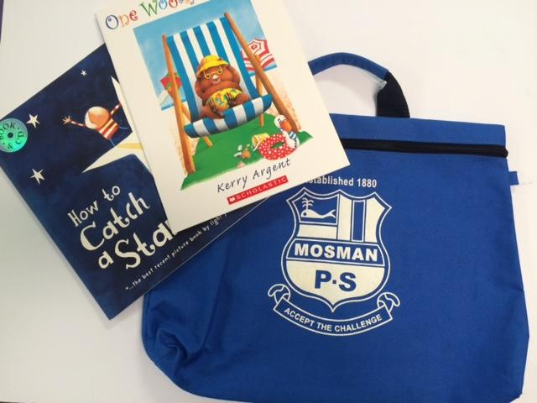
- jumper
- socks
- shoes
- raincoats [umbrellas are not permitted]
- school bag [first name only on the outside]
- library bag [first name only on the outside]
- drink bottle
- food container
Once Your child has Started School

Morning routine
Lessons start at 9.00am, so to ensure your child is not unsettled and to avoid disrupting the class, it would be appreciated if your child arrives before 9.00am. Students should arrive at school between 8.45am and 8.55am. This gives them some time to settle and play with their friends before school starts. Students arriving after 9.00am will be marked as partially absent and will require a late note from the office. There is a teacher on duty in the playground from 8.30am. Students are not to arrive at school before 8.30am.

Once your child arrives at school, they should place their bag on their allocated class lines. In order for your child to easily identify their own bag it would be beneficial to have a clear and visible bag tag. In order to develop independent and responsible students, we ask that you assist your child in packing their own bag each morning. Students will be required to unpack their own bag once they go to class with the teacher and place their drink bottle, crunch 'n' sip, and reading folder in the allocated boxes.

When the 8.55am bell rings the students line up in their classes in the upper Myahgah playground where they will be greeted by their teacher and taken to the classroom.

Afternoon routine
When the 3.10pm bell rings the classroom teacher will bring all the students out to the playground to their class line in the upper Myahgah playground. Students will only be dismissed once the bell has gone and the person picking up has been sighted. Parents are to wait in the playground for their child and not at the classroom door as students tend to run to their parents as soon as they see them. This can make it difficult for the teacher to keep an eye on the rest of the class. [Please speak to your child about sitting down in their class lines until the bell has gone and their carer has been sighted, the teacher will teach students this at school, however, if you are giving them the same message, this will help them to remember]
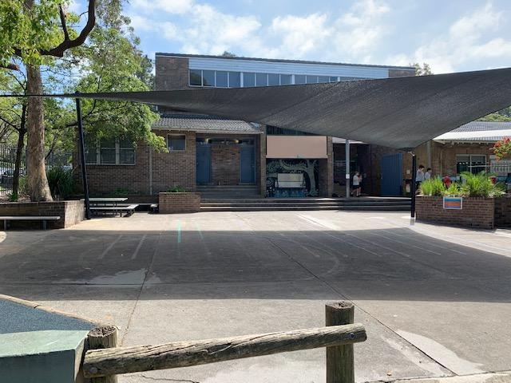

Kindergarten lines in the upper Myahgah playground

Eating at school

- Crunch & sip
Your child will need a small plastic container to bring their Crunch & Sip snack. Crunch & Sip snacks will be eaten at 10.00am in the middle of the first learning session. This snack must be a healthy raw fruit or vegetable and needs to be eaten within a 10 minute timeframe. A few pieces of a fruit or vegetable (not whole) will suffice. All students will be eating it in the classroom and then continuing on with their lessons. Your child will need a drink bottle [containing water only] to sip during the day. |  | 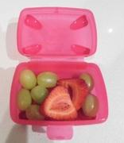
- Lunch
Supervised Eating Time  All students eat for 15 minutes with their classroom teacher [this will be longer in Term 1 for Kindergarten]. In Kindergarten, the teacher will check what each child has eaten. It is recommended that you practise opening and closing food containers, food packets and their drink bottle with your child.  Students who do not eat all their lunch are instructed to take it home in their lunch box. We do this so you can see what your child has (or has not) eaten. If the same things are coming home each day uneaten, it is a good indication that your child does not like that particular food, or that you are giving them too much. A sandwich, a piece of fruit, a snack and a drink seems to be the perfect size for most children.  Play Time  Students then have 40 minutes of playtime in the playground and are permitted to take their remaining food if they have not finished eating. |  | 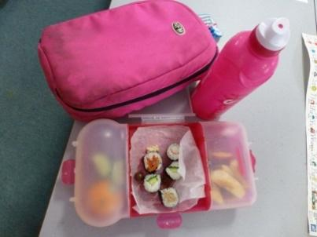
- Afternoon Tea
Please send afternoon tea in a separate container and not in their lunch box. We have found many children get upset when they find their lunch and afternoon tea mixed in together and do not know what they are supposed to eat for afternoon tea.  Students have 30 minutes to eat their afternoon tea, go to the bathroom and play. Please do not put too much food in the bag. One or two items are enough, e.g. a piece of fruit and a biscuit. |  | 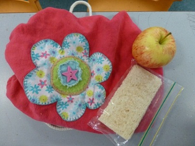
PLEASE NOTE THAT KINDERGARTEN STUDENTS DO NOT HAVE ACCESS TO THE CANTEEN FOR ORDERING AND PURCHASING DURING THE FIRST 6 WEEKS OF TERM 1

